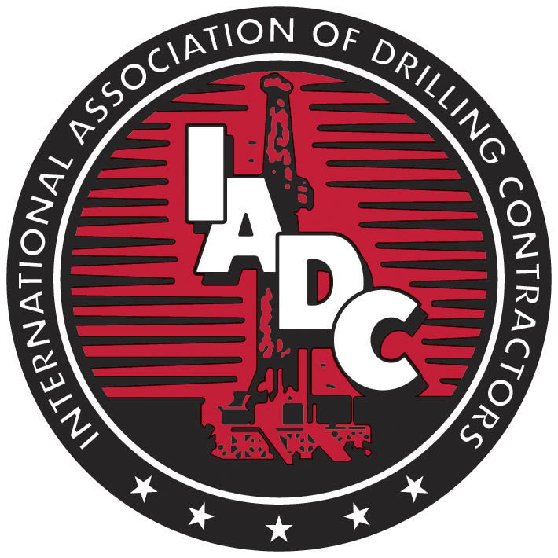 | Drilling Industry Training Accreditation System  Form DIT-04 ACCREDITATION AND AUDIT POLICY AGREEMENT

Contingent on receipt of accreditation by the International Association of Drilling Contractors ("IADC"), the Program submitting this application ("Program"), through the undersigned, as authorized representative of the Program, hereby agrees to the following conditions:
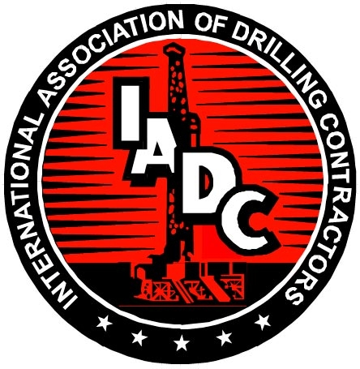

1. PROGRAM'S ACCREDITATION DUTIES

The Program voluntarily agrees to accept IADC's accreditation standards and to submit necessary information for participation as an accredited program in accordance with procedures set forth in the Overview and Accreditation Procedures (Form DIT-01). Failure to submit necessary supporting information and to abide by accreditation standards shall be due cause for revoking this agreement and any accreditation which has been granted to the Program.

2. ACCREDITATION DETERMINATION

The Program shall be deemed "accredited" when the Accreditation Panel (Panel) has determined that the applicant meets Program standards and has issued a formal certificate to applicant enabling applicant to publicly stipulate the Program's compliance with accreditation procedures and standards. Program may publicly display said certificate only during such period as the Program is in compliance with the accreditation procedures and standards. Program shall not display the certificate when the necessary Panel's finding of compliance has been withheld or withdrawn. Subject to the right of due process appeal defined in the Accreditation Procedures, Program shall abide by the decision of the Panel as to the compliance or noncompliance of Program with applicable accreditation standards. Program shall not permit the display or use of the certificate other than as permitted by the Panel and the terms of this agreement and the Accreditation Procedures. Use of the certificate in contravention of this agreement will be due cause for IADC to revoke this Agreement and to issue a public announcement to this effect in accordance with the provisions of the Overview and Accreditation Procedures.

3. DIRECTORY OF ACCREDITED PROGRAMS

IADC shall prepare and publish periodically, as it deems appropriate, a Directory of Accredited Programs containing a list of all, which are accredited at the time of each publication. IADC shall publish periodic bulletins to include any additions to or deletions from the Directory.

4. PROGRAM ACCREDITATION PROCEDURES

Both IADC and the Program shall follow and be controlled by the procedures and rules regarding the formulation of standards, reporting of information, complaints, representation of program status, display of formal certificates of participation in the Program, and due process appeals from decisions of the Panel and other matters to which this Agreement refers, as set forth in the Accreditation Procedures developed and periodically reviewed and updated by IADC.

5. PROGRAM'S GOOD FAITH COMPLIANCE

Program shall use all practical means at its disposal continuously to assure that the services it provides fully comply with the applicable accreditation standards at all times.

6. RIGHT TO AUDIT

When a site visit to audit a Program is required, requested, or otherwise deemed necessary or desirable by IADC, the IADC notifies the Program of the approximate dates of a site visit. If a site visit is declined and cannot be rescheduled to the mutual agreement of the Panel, IADC Staff and the Program, the school will be placed on probation, notwithstanding the provisions of appeal in the Accreditation Procedures. Upon scheduling a site visit, the IADC selects, from a list of names it has approved, the Site Visitor(s). Detailed arrangements for the visit are made through direct contact between the Program and the Site Visitor(s).

7. CHARGES OF PROGRAM NONCOMPLIANCE

Program agrees that if a claim of noncompliance with Accreditation Procedures or standards is filed against Program, it will promptly comply with any requests of the Panel for necessary information. Program agrees to reimburse IADC for any expenses related thereto, unless the claim was filed by another Program and is found to be without merit, in which case the charging Program shall reimburse IADC for said expenses. Program agrees to reimburse IADC for expenses incurred in connection with a merit less charge that it files.

8. ACCREDITATION STATUS REPRESENTATION

When reference is made to Program accreditation at any time, only the following shall be referred to or used: 1) the term “IADC Accreditation Pending,” which may be used by a Program that has made application for accreditation, until that time it is notified of the Panel’s decision regarding accreditation; 2) the term "IADC Accredited" which may be used by Program that has been notified that it has received either conditional or full accreditation; 3) an official certificate or stamp issued by IADC, provided such certificate or stamp shall be printed in full, without alteration of any kind; or 4) a logo and trademark owned by IADC and whose nonexclusive use by Program is hereby licensed to Program upon official notification that it has received full accreditation. IADC shall have the right to notify Program of any material used or issued by Program that IADC considers to be misleading to the public in regard to any reference to IADC or to Program's accreditation, and Program agrees on receipt of notice from IADC to terminate use of such materials and take such other steps as IADC may deem appropriate in the public interest.

9. INDEMNIFICATION AND HOLD HARMLESS

Program agrees to indemnify and hold harmless IADC, the Panel and their directors, officers, members, employees and agents from and against any and all liability, loss, damages, costs, or expenses, including reasonable attorneys fees, which they may incur, suffer, or be required to pay by reason of, or in consequence of, Program's actions, or breach of this Agreement or any acts or omissions of IADC or the Panel in respect to the right granted hereunder to obtain and to represent accreditation status or to display formal accreditation certificates, or that may be sustained or incurred in making any investigation on account of any claim, loss, cost, damage, or expense, or in defending or prosecuting any action, suit, or other proceeding that may be brought in connection therewith, or in enforcing any of the obligations herein contained, or in obtaining a release from liability in connections therewith.

10. DURATION AND TERMINATION OF AGREEMENT

Program agrees that IADC may, on ten days written notice to Program, terminate this Agreement for any of the causes set forth in this Agreement and in accordance with the due process stated in the Accreditation Procedures.

___________________________________________________________
Name of Company or Institution

___________________________________________________________ ______________________
Signature of Program Administrator or Responsible Person Date

___________________________________________________________
Printed or Typed Name of Program Administrator or Responsible Person

____________________________________________________________
Title

